
ATAR Biology

Unit 1: Topic 4
Conservation



Student Study Notes

Unit Content
- Conservation strategies used to maintain biodiversity are
  - genetic strategies, including gene/seed banks and captive breeding programs
  - environmental strategies, including revegetation and control of introduced species
  - management strategies, including protected areas and restricted commercial and recreational access
- Identification and classification of an ecological area as a conservation reserve also requires consideration of the commercial and recreational uses of the area, as well as Indigenous Peoples’ usage rights.
- Australia’s Biodiversity Conservation Strategy 2010–2030 presents a long-term view of the future and the actions that need to be implemented to conserve biodiversity.
- International agreements about biodiversity encourage international cooperation in the protection of unique locations, including
  - World Heritage sites, for example, Shark Bay, Great Barrier Reef
  - biodiversity hotspots, for example, south west WA
  - international migration routes and areas used for breeding, for example, by birds, whales, turtles, whale shark

Conservation Strategies
Conservation strategies used to maintain biodiversity are:
- genetic strategies, including gene/seed banks and captive breeding programs
- environmental strategies, including revegetation and control of introduced species
- management strategies, including protected areas and restricted commercial and recreational access
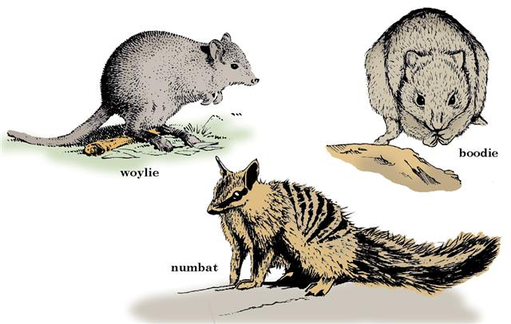

Environmental strategies | Reason
reduce introduced species | maintain biodiversity and prevent extinction
revegetation | re-establish native vegetation
use biological control | reduce pest numbers

Genetic strategies | Reason
captive breeding programs | prevent extinction and reintroduce into the wild
seed banks | preserve a rare or threatened plant species

Management strategies | Reason
protected areas | maintain biodiversity and prevent extinction
restricted commercial and recreational access | prevent spread of disease

Biodiversity hotspots

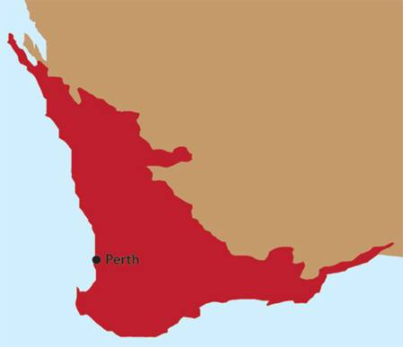
Biodiversity 'hotspots' are regions of high conservation value.
To qualify as a hotspot, a region must contain many unique and endemic plant species and be subject to serious levels of habitat loss.

Biodiversity hotspots are found across every continent except Antarctica. The South-West of Australia is an example of a biodiversity hotspot.

The South-West (of Australia) is a designated biodiversity hotspot where nearly 80 per cent of the plant species are found nowhere else in the world, including many species of banksia such as Banksia coccinea.

The primary cause of habitat loss in the South-West (of Australia) has been agricultural practises such as deforestation. Native fauna are under threat from introduced species such as the fox. Other animal species under threat in the South-West (of Australia) include the Woylie, western quoll (Chuditch), dibbler, numbat, quokka, Gilbert's potoroo, woma, Lancelin island skink, malleefowl, Carnaby's cockatoo, white-bellied frog, orange-bellied frog and sunset frog.

For more information on biodiversity hotspots, visit:
www.environment.gov.au/biodiversity
www.perthzoo.wa.gov.au
(Type biodiversity hotspots into the search function on the website.)

Australia’s Biodiversity Conservation Strategy 2010–2030
Australia’s Biodiversity Conservation Strategy 2010–2030 presents a long-term view of the future and the actions that need to be implemented to conserve biodiversity.
International agreements about biodiversity encourage international cooperation in the protection of unique locations, including
- World Heritage sites, for example, Shark Bay, Great Barrier Reef
- biodiversity hotspots, for example, south west WA
- international migration routes and areas used for breeding, for example, by birds, whales, turtles, whale sharks

A copy of this document is available on Moodle. Have a read and review the Priorities and Actions/Implementations sections in particular.

PRACTICE QUESTIONS:

1. What is the aim of conservation?

2. What is biodiversity and why should it be maintained?

3. Why have seed banks been established?

4. The Millennium Seed Bank Project aims to conserve the seeds of 10% of the world's seed-bearing plants. These seeds are mainly from the world's dry regions. Explain why it is important to preserve seeds from the world's dry regions.

Use the Australia’s Biodiversity Conservation Strategy 2010–2030 document available on Moodle to answer the next three questions.

5. List three principles underpinning the Strategy.

6. List the three priorities for action.

7. Give an example of how each ‘priorities for action’ may be achieved.

Source: Academic Task Force Sem1 2019
8. Which of the following would be LEAST likely to be recognized as a major priority in the 2010 – 2030 Australian Biodiversity Conservation Strategy?

- Engaging all Australians in biodiversity conservation.
- Building ecosystem resilience to climate change by protecting biodiversity, maintaining ecosystem functions and reducing threats to biodiversity.
- Generating measurable improvements in biodiversity by sharing knowledge, delivering conservation strategies and evaluating conservations strategies.
- Development of a vaccine and the resulting vaccination of all Tasmanian Devils so as to protect the species from Devil Facial Tumor Disease.

9. Gene banks are important because they:

- Hold seeds of a variety of plants.
- Are a genetic reservoir of the variety of life on Earth.
- Are found at the Western Australia Herbarium and Kings Park.
- Store genetic material of useful organisms to humans.
10. Which of the following is NOT an example of a management strategy that may be used to protect wildlife?

- Establishing a protected area.
- Restricted commercial access to an area.
- Restricted recreational access to an area.
- Revegetating an area of bushland.

11. The Perth Zoo has been involved in captive breeding of Numbats since 1993. In the summers of 2016/17, 2017/18 and 2018/19 captive bred Numbats were released at Mount Gibson Wildlife Sanctuary, 350km northeast of Perth.

- Describe two (2) ways Mount Gibson Wildlife Sanctuary would have been prepared to enable successful release and future breeding of Numbats.

- Describe four (4) strategies that the Zoo must consider when breeding and preparing Numbats for release.

- Provide an explanation as to how climate change may impact the Numbat.

Practice Extended Response
12. There are many species of animal that migrate long distances from one area of the earth to another.

- Name one such species and describe its migration journey.

- Explain the importance of international agreements and co-operation in the protection of the migratory species.
(10 marks)

Source: EdWest Sem1 2017
13. A highly threatened plant species with a distribution across a National Park and an area being logged by “clear felling” was recently classified as an “endangered species”.

Which of the following would be least effective in preserving this species?

- A public awareness campaign
- Creating a seed bank
- A legislative ban on land clearing
- Increasing the size of the National Park

14. A local group of environmentalists were keen to preserve a woodland community from any clearing and efforts to re-establish the grassland for grazing cattle.

What considerations would need to be considered by the environmentalists in writing such a submission to the local government and community?

